**Course: Advance Bio Informatics**

**Module Title: Target Discovery Strategy**

**Module No: 130**

**Target Discovery Strategy**

Target discovery to clinical application saga

* Physiology-based approach
* Target-based approach

**Physiology-based approach**

Is a disease-centric approach in which target is not identified, multiple targets are involved. In vivo screening is done by using drugs, siRNA or antisense oligonucleotides.

This process relies on disease, not on the target.

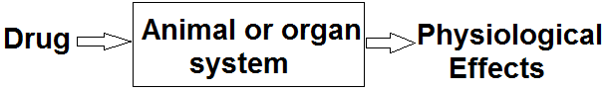

**Target-centric** **approach**

Target based discovery starts with the identification of genes and their protein products. Aim to develop drugs affecting one gene or a molecular mechanism. The identification of disease-relevant genes in vitro cellular models has been possible due to several tools. Gene-suppression tool used to link the genes with disease.

Target has two types

* Genetic
* Mechanistic

**Genetic targets** are represented by genes and genes products.

**Mechanistic targets** include mechanism based targets such as receptors, enzymes or genes, identified on the basis of the disease state.

